
Data Security Envisioning Workshop
30-Statement of Work Template
v8.5 - January 2026

Table of Contents
Disclaimer 3
Version History 4
1 Introduction 5
1.1 About the Data Security Envisioning Workshop 6
1.2 What is the Data Security Check? 7
1.3 What are the Data Security Check optional modules? 8
2 Engagement objectives 9
3 Engagement Scoping 10
3.1 In-scope activities for the Data Security Envisioning Workshop 10
3.2 In-scope activities for the Data Security Check 10
3.3 Out of scope for the Data Security Envisioning Workshop 12
3.4 Engagement deliverables 12
3.5 Customer requirements 13
3.5.1 Customer resources 13
3.5.2 Partner resources 14
3.5.3 Other resources 15
4 Schedule and Timelines 16
4.1 Week 1 - Prepare for delivery 17
4.2 Week 2 - Configure and enable 18
4.3 Week 3 - Automated Discovery continues 19
4.4 Week 4 - Analyze, report and workshop 20
5 Effort 21

Disclaimer
The Data Security Envisioning Workshop provides a summary of an organization’s data protection and compliance stature and recommendations to improve data protection and compliance.
The information, results, and scoring provided through the Data Security Envisioning Workshop are recommendations and provided for general informational purposes only. They do not constitute legal advice, certifications, or guarantees regarding regulatory compliance; it is up to each organization to evaluate the effectiveness of these recommendations in their respective regulatory environment prior to implementation. Organizations should consult with their own legal professionals to determine how standards or regulations apply to their organization and how to best ensure compliance.
We hope the Data Security Envisioning Workshop helps identify technologies and additional steps that organizations can implement to simplify their compliance efforts.
MICROSOFT MAKES NO WARRANTIES, EXPRESS, IMPLIED, OR STATUTORY, AS TO THE INFORMATION IN THIS Data Security Envisioning Workshop. Microsoft disclaims any conditions, express or implied, or other terms that use of the Microsoft products or services will ensure the organization’s compliance with regulations or standards. This Data Security Envisioning Workshop toolkit is provided “as-is.” Information and recommendations expressed in the Data Security Envisioning Workshop may change without notice.
The Data Security Envisioning Workshop does not provide the user with any legal rights to any intellectual property in any Microsoft product or service. Use of the tool is for internal, reference purposes only; however, Microsoft partners may distribute the Data Security Envisioning Workshop toolkit to their customers for such customers’ internal, reference purposes only. Any distribution of the Data Security Envisioning Workshop toolkit by a Microsoft partner to its customers must include terms consistent with those set forth in this disclaimer.
© 2026 Microsoft. All rights reserved.

Version History
Version | Author | Changes | Date
1.0 | François van Hemert | First published v1 release. | November 2019
2.0 | François van Hemert  Wayne Anderson | First published v2 release. | June 2020
2.1 | François van Hemert | Maintenance release, minor updates. | November 2020
3.0 | François van Hemert | Introduced modular design, added Compliance Manager activity. | January 2021
3.1 | François van Hemert | Added Teams Data Loss prevention. | February 2021
4.0 | François van Hemert | Workshop split, update to align with new narrative, rebranding, updates to guidance and organized around data repositories. | June 2021
4.1 | François van Hemert | Update with Compliance Manager Premium Assessments. | October 2021
4.2 | François van Hemert | Purview branding update, step-by-step guidance update to align with changes M365. | July 2022
4.2.1 | François van Hemert | Updated Microsoft Compliance Configuration Analyzer to Configuration Analyzer for Microsoft Purview. | July 2022
4.2.2 | François van Hemert | Updated version number to align with kit, no content updates. | January 2023
6.0 | François van Hemert | Workshop merge, align with FY24 solution play, focus on Data Security. | August 2023
6.5 | François van Hemert | Update to align with FY25 solution play | July 2024
6.6 | François van Hemert | Version number update for alignment, no content changes | October 2024
7.0 | François van Hemert | Added the Data security for generative AI module | January 2025
7.1 | François van Hemert | Version number update, no further changes | May 2029
8.0 | François van Hemert | Update to align with current product features and functionality (evergreen), update name, update branding. | July 2025
8.5 | François van Hemert | Update to align with current product features and functionality (evergreen) | January 2026

Introduction
Data is vital for every business. IDC forecasts that the datasphere will double in size by 2026. Data will be ubiquitous and will keep growing exponentially in the future. Data generates insights that help run businesses, provides a competitive edge in the market, and enables employees to work together and stay efficient.
Today, data is used beyond the normal boundaries of business. Data is stored on-site, in multiple clouds, on devices, and more. It is being accessed from within and outside the corporate networks.
With the fast adoption and deployment of generative AI apps, more data will be produced at a faster rate. The risks involved in using and launching generative AI apps are not yet fully known and because of this they are increasing the demand for securing and governing the data input and output.
With this increase in data, data security incidents are common and rising, costing organizations millions of dollars every year to resolve.
Our customers need to secure and manage their data, but they often find it a complex and multi-faceted challenge.
Securing data is becoming harder as the data and its sources multiply - different kinds of data need different levels of protection. Applying general policies without knowing what data you have is not an efficient approach. It is estimated that about 30% of decision makers are unaware of the location or nature of their sensitive business-critical data, lacking full visibility in their digital estate.
Data does not move itself; people move data – it is important that organizations understand how data is being used and shared in their organization. Every organization has different kinds of data, different kinds of users, and they have different goals they want to achieve – there is no one size fits all strategy.
Organizations need to first understand the data security risks they face – this starts with getting visibility into what data they have, where it is stored and how their users are interacting with that data. Without this visibility, it is not possible to effectively protect the data.
This Statement of Work describes the Data Security Envisioning Workshop that <Partner Name> will engage in with <Customer Name> to help <Customer Name> assess their data security, privacy, and regulatory requirements; address their most pressing data security goals and challenges; and provide an immersive experience that brings to life Microsoft’s vision and capabilities with respect to data security, privacy, and regulatory compliance.
The objective for the Data Security Envisioning Workshop is to help customers understand how Microsoft 365 services and products can mitigate and protect against data security risks.

Sources:
- Microsoft Data Security Index report
- First Annual Generative AI Study: Business Rewards vs. Security Risks, Q3 2023, ISMG, N=400
- March 2023 survey of 510 US compliance decision makers commissioned by Microsoft from agency Vital Findings
- Gartner, Security Leader’s Guide to Data Security, ​Andrew Bales, Sep 2023
PLACEHOLDERS
Update all placeholders for
<Customer Name> and
<Partner Name>
to reflect the actual customer and partner name,
Delete this textbox before publishing.

About the Data Security Envisioning Workshop
The Data Security Envisioning Workshop is a <partner / Microsoft Field / Microsoft Global Partner Solutions> -led engagement that helps land the Microsoft Purview vision and its value proposition with customer’s. business decision makers.
Who will deliver?
Select who will be delivering the engagement. Remove all non-relevant other mentions of delivery resources.
Delete this textbox before publishing.

The Data Security Envisioning Workshop is powered by the Data Security Check. The Data Security Check is a structured engagement that leverages a subset of Microsoft Purview products, services, and features to gain visibility into existing, and at sometimes hidden, data security risks that may exist in the data that resides in the customer’s Microsoft 365 cloud environment <and on customer premises>.
The outcome and findings of the Data Security Check serve as input to the overall engagement and will be used to create awareness and identify potential areas for mitigation.
Where does the data reside?
If the customer decides not to include the on-premises data stores in the
Data Security Check, remove
<and on customer premises.>
Delete this textbox before publishing.

Ultimately, the Data Security Envisioning Workshop will help customers understand how Microsoft Purview services and products can mitigate and protect against the real data security risks identified during the engagement.

What is the Data Security Check?
The Data Security Check is an integral part of the Data Security Envisioning Workshop. The Data Security Check leverages Microsoft Purview tools and services in an automated process to:
- Discover data that is stored in the Microsoft 365 Cloud and analyze it for the presence of artifacts that may impose data security risks to the organization.
- Analyze user behavior for events that may impose a risk to the organization. These vulnerabilities include, but are not limited to the loss of intellectual property, workplace harassment, and interaction with unmanaged or unsanctioned generative AI applications.
The Data Security Check is structured around typical Microsoft 365 services and their associated data repositories that organizations use. At its core, the Data Security Check analyzes user behavior and scans data repositories related to email, collaboration, and document storage. Optional modules can be added to extend the Data Security Check to include on-premises data repositories, Windows 10/11 endpoints, interactions with generative AI applications and more. All activities share a common set of activities for setup and configuration, write-up, and decommissioning as depicted in the illustration below.
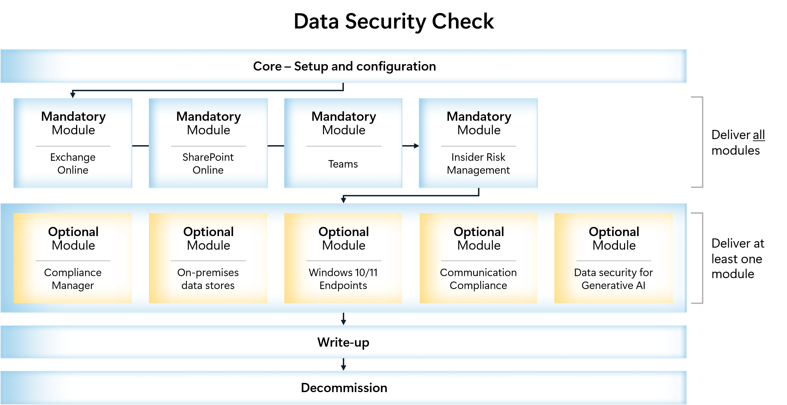
Optional Modules.
In addition to the Mandatory modules that will always be delivered as part of the
Data Security Envisioning Workshop.
The delivery must also include at least one (1) optional module.
Update the illustrations above to the agreed engagement scope by removing the optional modules that are not part of the engagement The illustration can be found in
<90 - Supporting Illustrations.pptx>
that is included in the toolkit.
Delete this textbox before publishing.

What are the Data Security Check optional modules?
The mandatory modules of the Automated Discovery process focus on identifying data security risks in data the customer has stored in the Microsoft 365 Cloud and analyzing user behavior for events that impose a risk to the customer’s organization. In addition to these mandatory modules, <Customer Name> has chosen to include the following additional modules in the Data Security Check scope:
- Module - Compliance Manager. Assess the customer’s Microsoft 365 environment against the Data Protection Baseline and one or more customer-specific assessments that can help the organization comply with national, regional, and industry-specific requirements governing the collection and use of data.
- Module – On-premises data stores. Scan on-premises data repositories such as file shares and SharePoint Server libraries using Microsoft Purview Information Protection scanner.
- Module – Windows 10/11 endpoints. Detect malicious and inadvertent risk activities on local workstations using Microsoft Purview Microsoft Purview Data Loss Prevention for Endpoints.
- Module – Communication Compliance. Discover privacy and regulatory risks by evaluating user communication inside the organization.
- Module – Data security for generative AI. Prepare for generative AI and identify the potential risks of Shadow AI, discover sensitive information being shared with generative AI applications and identify locations with potential risk of oversharing.
Optional modules.
At least one (1) optional module must be included in the Data Security Envisioning Workshop.
Additional modules can be included per customer request.
Remove modules that are not included in the Data Security Envisioning Workshop scope.
Delete this textbox before publishing.

Delete this textbox before publishing.

Engagement objectives
The objectives for the Data Security Envisioning Workshop are:
- Discover data security risks.
Gain visibility into existing, and at sometimes hidden, data security risks that may exist in the customer’s organizational data.
- Understand how to mitigate identified risks.
Help customers to better understand, prioritize, and mitigate the identified risks across the Microsoft Cloud and optionally on-premises data repositories.
- Provide recommendations and define next steps.

Engagement Scoping

In-scope activities for the Data Security Envisioning Workshop
The following activities are in-scope for the Data Security Envisioning Workshop:
- Pre-engagement meeting, an online meeting organized one to two weeks prior to the actual delivery activities to discuss upcoming activities, align expectations, discuss resource requirements, and establish timelines.
- Data Security Check, implementation and configuration of a subset of Microsoft Purview products and services to enable Automated Discovery of hidden data security risks that may exist in the organization’s data. For an overview of the in-scope activities for the Data Security Check, refer to section 3.2.
- Microsoft Purview portfolio overview, introduce the Microsoft Purview vision and outline Microsoft’s approach to providing integrated regulatory compliance.
- Recommendations and next steps, mapping the findings and risks that were identified by the Data Security Check to Microsoft Purview products and services, and defining actionable next steps for risk mitigation.

In-scope activities for the Data Security Check
The Data Security Check scope includes:
- Definition and identification of Sensitive Information Types that may impose data security risks to <Customer Name>’s organization.
- Enable the Automated Discovery service to:
  - Search for sensitive information stored in Microsoft 365 data repositories.
  - Identify stale data stored in Microsoft 365 data repositories.
  - Monitor for suspicious and unusual user activity related to sensitive information in Microsoft 365 data repositories.
  - Identify improvement actions and suggest the implementation of controls that can help improve <Customer Name>’s compliance posture (05-Module Delivery Guide-Compliance Manager).
  - Discover data security risks in on-premises data repositories (06-Module Delivery Guide-On premises).
  - Identify risky activity, privacy and regulatory risks on Windows 10 and Windows 11 devices (07-Module Delivery Guide-Windows Endpoints).
  - Discover corporate policy violations or unwanted behavior that can contribute to insider risks by evaluating user communication inside the organization (08-Module Delivery Guide-Communication Compliance).
  - Prepare for generative AI and identify the potential risks of Shadow AI, discover sensitive information being shared with generative AI applications and identify locations with potential risk of oversharing. (09-Module Delivery Guide-Data Security for AI)
OPTIONAL ACTIVITIES
Remove a highlighted activity when it is not part of the engagement.
Delete this textbox before publishing.
- Enable Microsoft 365 services used by the Data Security Check Automated Discovery process:
  - eDiscovery Search
  - Data Loss Prevention
  - Insider Risk Management
  - Microsoft Purview Information Protection
  - Audit
  - Compliance Manager (required for 05-Module Delivery Guide-Compliance Manager).
  - Purview Information Protection scanner (required for 06-Module Delivery Guide-On premises> ).
  - Data Loss Prevention for Endpoints (required for 07-Module Delivery Guide-Windows Endpoints).
  - Communication Compliance (required for 08-Module Delivery Guide-Communication Compliance).
  - DSPM for AI (required for 09-Module Delivery Guide-Data Security for AI)
OPTIONAL ACTIVITIES
Remove above highlighted products or services when they are not part of the engagement.
Delete this textbox before publishing.

Out of scope for the Data Security Envisioning Workshop
Any area that is not explicitly listed in the “in-scope” section as “within scope” is out of scope for this engagement. The areas that are out of scope for this engagement include, but are not limited to, the following:
- Discovery activities for other cloud services. The Data Security Check does not include discovery activities for third-party cloud services such as, but not limited to, AWS, Box, and Google Drive.
- Proof of concept or lab deployment. The standard scope of the Data Security Check does not include deployment of the solution in a development or proof of concept environment.
- Creation of a data labelling taxonomy. The standard scope of the Data Security Check does not include defining and designing a data labeling taxonomy.
- Creation of data retention policies or schedules. The standard scope of the Data Security Check does not include marking any data discovered during the Automated Discovery for retention or deletion.
- Labeling discovered documents or data. The standard scope of the Data Security Check does not include applying labels to data or documents identified during the Automated Discovery.
- Identify improvement actions and suggest the implementation of controls that can help improve <Customer Name>’s compliance posture.
- Discover data security risks in on-premises data repositories.
- Identify risky activity, privacy and regulatory risks on Windows 10 and Windows 11 devices.
- Discover corporate policy violations or unwanted behavior that can contribute to insider risks by evaluating user communication inside the organization.
- Identify risks associated with the use of generative AI.
OPTIONAL ACTIVITIES
Remove highlighted products or services when they are included in the engagement.
Delete this textbox before publishing.

Engagement deliverables
The deliverables for the Data Security Envisioning Workshop have been defined as:
- Data Security Check findings overview, lists and interprets data security risks identified by the Automated Discovery process and observed during this engagement.
- Data Risk Management recommendations, maps the observed data security risks to Microsoft Purview products in order to mitigate impact and improve the organization’s compliance posture.
- Recommended activities and next steps, list of actionable next steps that will help improve <Customer Name>’s compliance posture and mitigate the identified risks.
Note
All deliverables are part of the close-out presentation that will be delivered as the last activity of the Data Security Envisioning Workshop.

The deliverables will be submitted to the customer for review and approval after the completion of the close-out presentation.
Within three business days of the date of submittal, the customer is required to:
- Accept the deliverable by signing, dating, and returning a service deliverable acceptance form, which can be sent by email or by using (or partially using) the deliverable.
-Or-
- Reject the deliverable by notifying <Partner Name> in writing; <Customer Name> must include a complete list of reasons for rejection.

Deliverables shall be deemed accepted unless the written rejection notification is received by <Partner Name> in the timeframe specified.
If a rejection notification is received, <Partner Name> will correct the problems with a deliverable that is in scope for the project, after which the deliverable is deemed accepted.

Customer requirements
Successful delivery of the Data Security Envisioning Workshop experience is dependent on the customer's involvement in all aspects of the engagement, the right partner delivery team, and having access to information and location facilities.

Customer resources
<Customer Name> will provide adequate access to the necessary personnel needed to successfully complete the engagement including:
Executive Sponsor
- Owns the business case.
- Keeps project aligned with organization's strategy and portfolio direction.
- Governs project risk.
- Focuses on realization of benefits.
- Provides assurance.
- Suggested candidates: CCO, CSO, CISO, CEO, CFO, CIO, or CTO.
Architects
- IT-Architect - provides overall architectural guidance and insights.
- Compliance Architect - provides architectural guidance and insights into privacy and regulatory requirements and standards.
- Security Architect - provides architectural guidance and insights into security policies and standards.
Administrators
- Compliance & Security Administrator - provides technical guidance and insights into currently deployed controls.
Tenant Administrators
- Microsoft 365 Tenant Administrator - provides insights into existing use of Microsoft 365 and access to tenant and service configuration.
Project or Engagement Manager (optional)
- Basic understanding of regulatory compliance.
- Basic understanding of Information Protection and Data Lifecycle Management products.
- Experience managing regulatory compliance engagements.
CUSTOMER RESOURCES
Update the list of customer resources based on discussions with the customer.
Delete this textbox before publishing.

Partner resources
<Partner Name> will provide the necessary personnel needed to successfully complete the engagement including:
Compliance Consultant / Compliance Advisor
- Good understanding of rules, regulations, and standards that are applicable to the customer’s organization.
- Can advise on data security risks and mitigation.
- Understands Microsoft products and services around regulatory compliance and security.
Optional resources
Project or Engagement Manager (optional)
- Basic understanding of regulatory compliance.
- Basic understanding of Microsoft Purview products.
- Experience managing regulatory compliance engagements.
Security Consultant (optional)
- Strong cybersecurity background and knowledge.
- Good understanding of Microsoft 365 and the security components of Microsoft 365.
- Good understanding of Azure and Azure Security Services.
PARTNER RESOURCES
Update the list of partner resources based on discussions with the customer.
Delete this textbox before publishing.

Other resources
<Customer Name> will provide the following to the partner resource(s):
- Access to any relevant documentation.
- Accurate and complete information in a timely fashion.
- Network connectivity, adequate workspace, parking permits, building access and appropriate identification badges within the first day of the on-site engagement.
- Appropriate-sized room with whiteboard and projector for knowledge transfer sessions.
OTHER RESOURCES
Update the list of other resources based on specific customer or delivery needs.
Delete this textbox before publishing.

Schedule and Timelines
The illustration below provides a high-level overview of all activities that are part of the Data Security Envisioning Workshop.
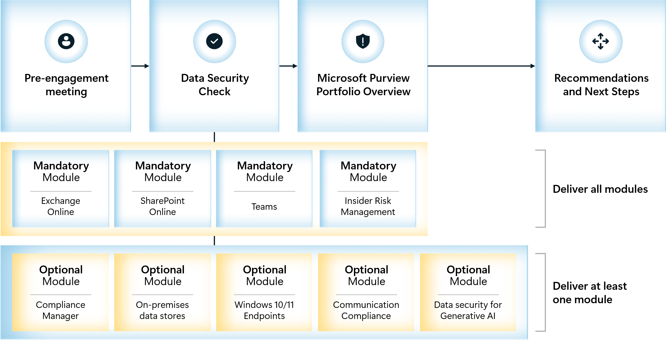
Optional Modules.
In addition to the Mandatory modules that will always be delivered as part of the
Data Security Envisioning Workshop,
the customer also must include at least one (1) optional module.
Update the illustrations above to the agreed engagement scope by removing the optional modules that are not part of the engagement The illustration can be found in
<90 - Supporting Illustrations.pptx>
that is included in the toolkit.
Delete this textbox before publishing.

Engagement activities will be delivered over a <four-week period>. The sections below describe the activities for each week.
DELIVERY PERIOD
Update the delivery period to align with the agreed schedule.
Delete this textbox before publishing.

Week 1 - Prepare for delivery
The engagement will start with a remote preparation meeting. This customer Pre-engagement meeting typically is an online meeting organized one week prior to the actual start of the engagement. During this online meeting, <Partner Name> will introduce <Customer Name> to the Data Security Envisioning Workshop, discuss the upcoming activities, and decide on the modules and activities to include. The objective for the online meeting is to align expectations and timelines. For customers that have had no prior exposure to the products and tools that will be used during the engagement, it is possible to include a high-level introduction and demo explaining the features and functionality. The remainder of the first week is intended to be used by <Customer Name> to arrange logistics, allocate resources, and prepare for the upcoming delivery.
The illustration below depicts the schedule for the first week of the engagement.
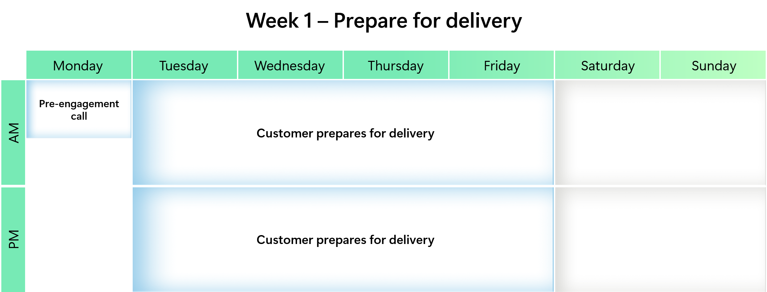
DELIVERY SCHEDULE
Update the delivery schedule using the PowerPoint file included in the toolkit:
<90 - Supporting Illustrations.pptx>
If the customer agrees to additional optional activities, add them to the schedule. Copy the updated illustrations to the statement of work.
Delete this textbox before publishing.

Week 2 - Configure and enable
The Kick-off meeting on the first day of the second week marks the actual start of the engagement delivery. By means of a short presentation, <Partner Name> will introduce the team to the upcoming activities, (re-)align expectations and confirm timelines and resource availability.
Next, <Partner Name> will work with <Customer Name> to configure and enable the required services and tools and start the Automated Discovery process that is part of the Data Security Check.
The illustration below depicts the schedule for the second week of the engagement.
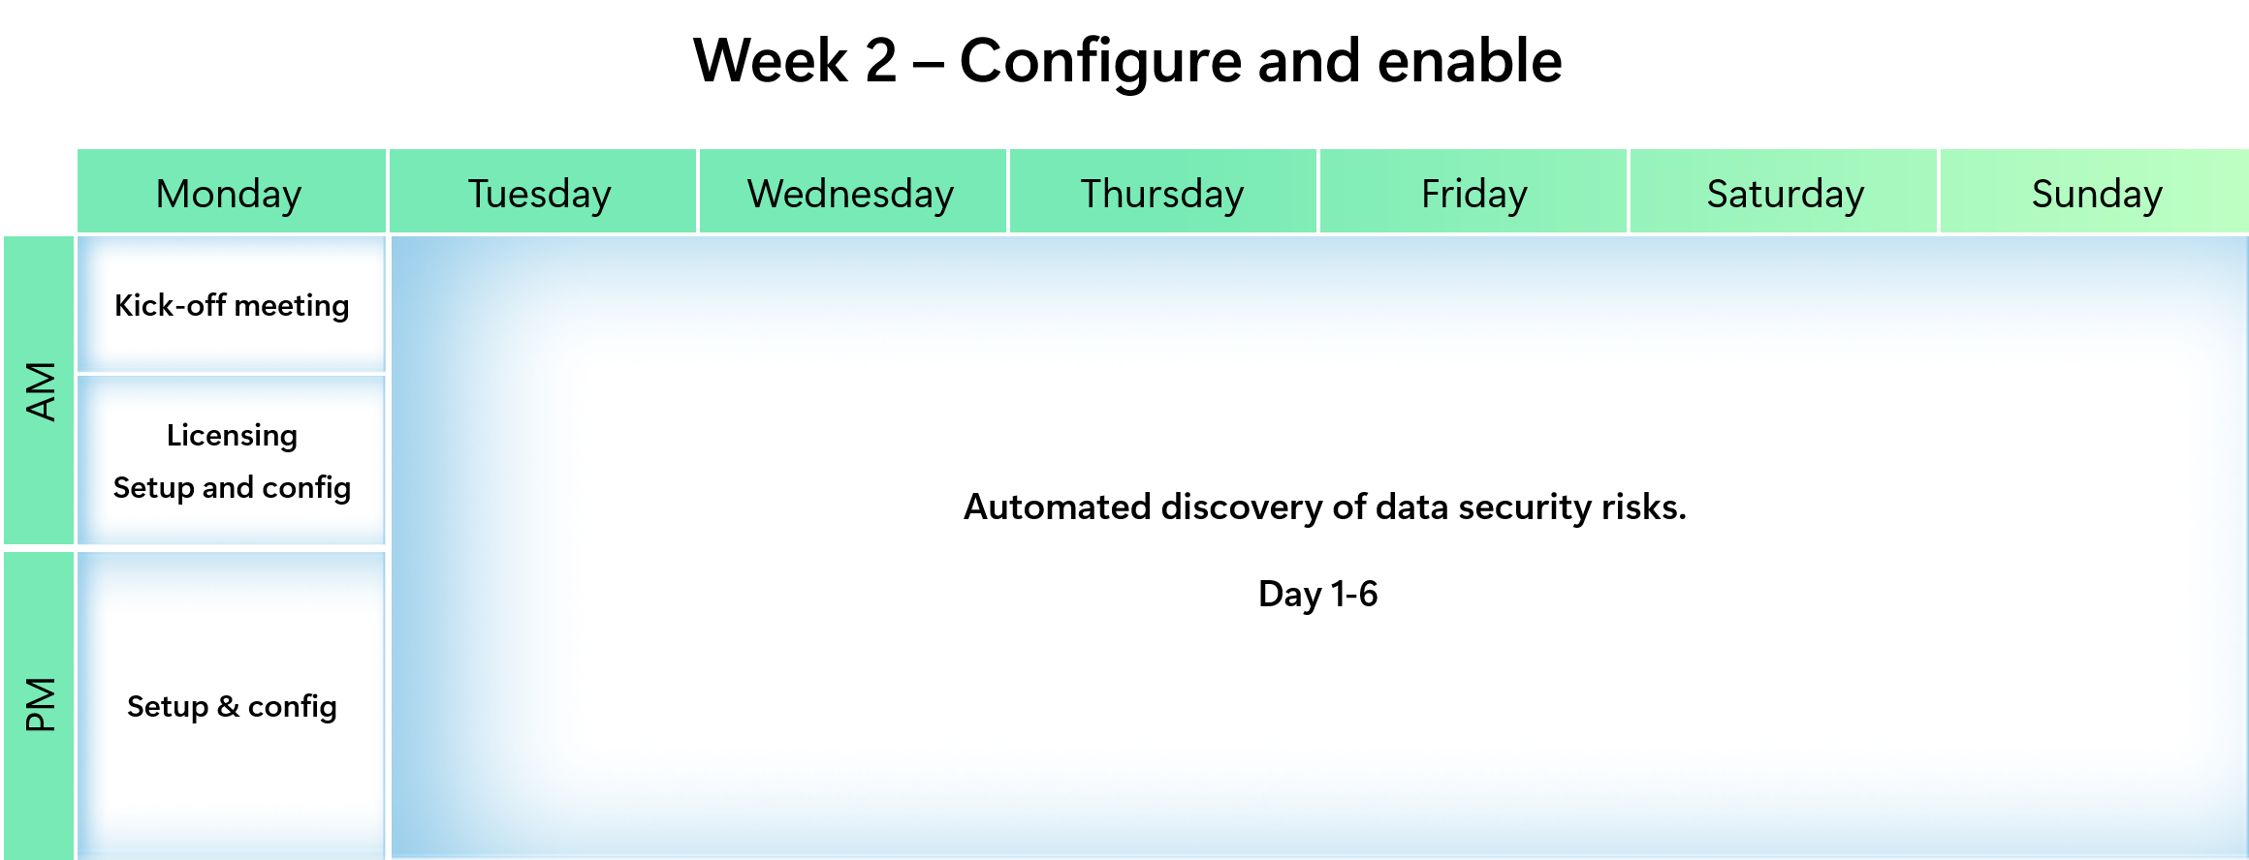

 Important
To ensure the results and findings represent a normal production setup, it is recommended to allow the Data Security Check Automated Discovery process to run for at least two weeks after enablement. From previous deliveries, we have learned that the Automated Discovery process needs at least two weeks to generate meaningful results.

DELIVERY SCHEDULE
Update the delivery schedule using the PowerPoint file included in the toolkit:
<90 - Supporting Illustrations.pptx>
If the customer agrees to additional optional activities, add them to the schedule. Copy the updated illustrations to the statement of work.
Delete this textbox before publishing.

Week 3 - Automated Discovery continues
During the third week of the engagement, the Data Security Check Automated Discovery process will continue to run.
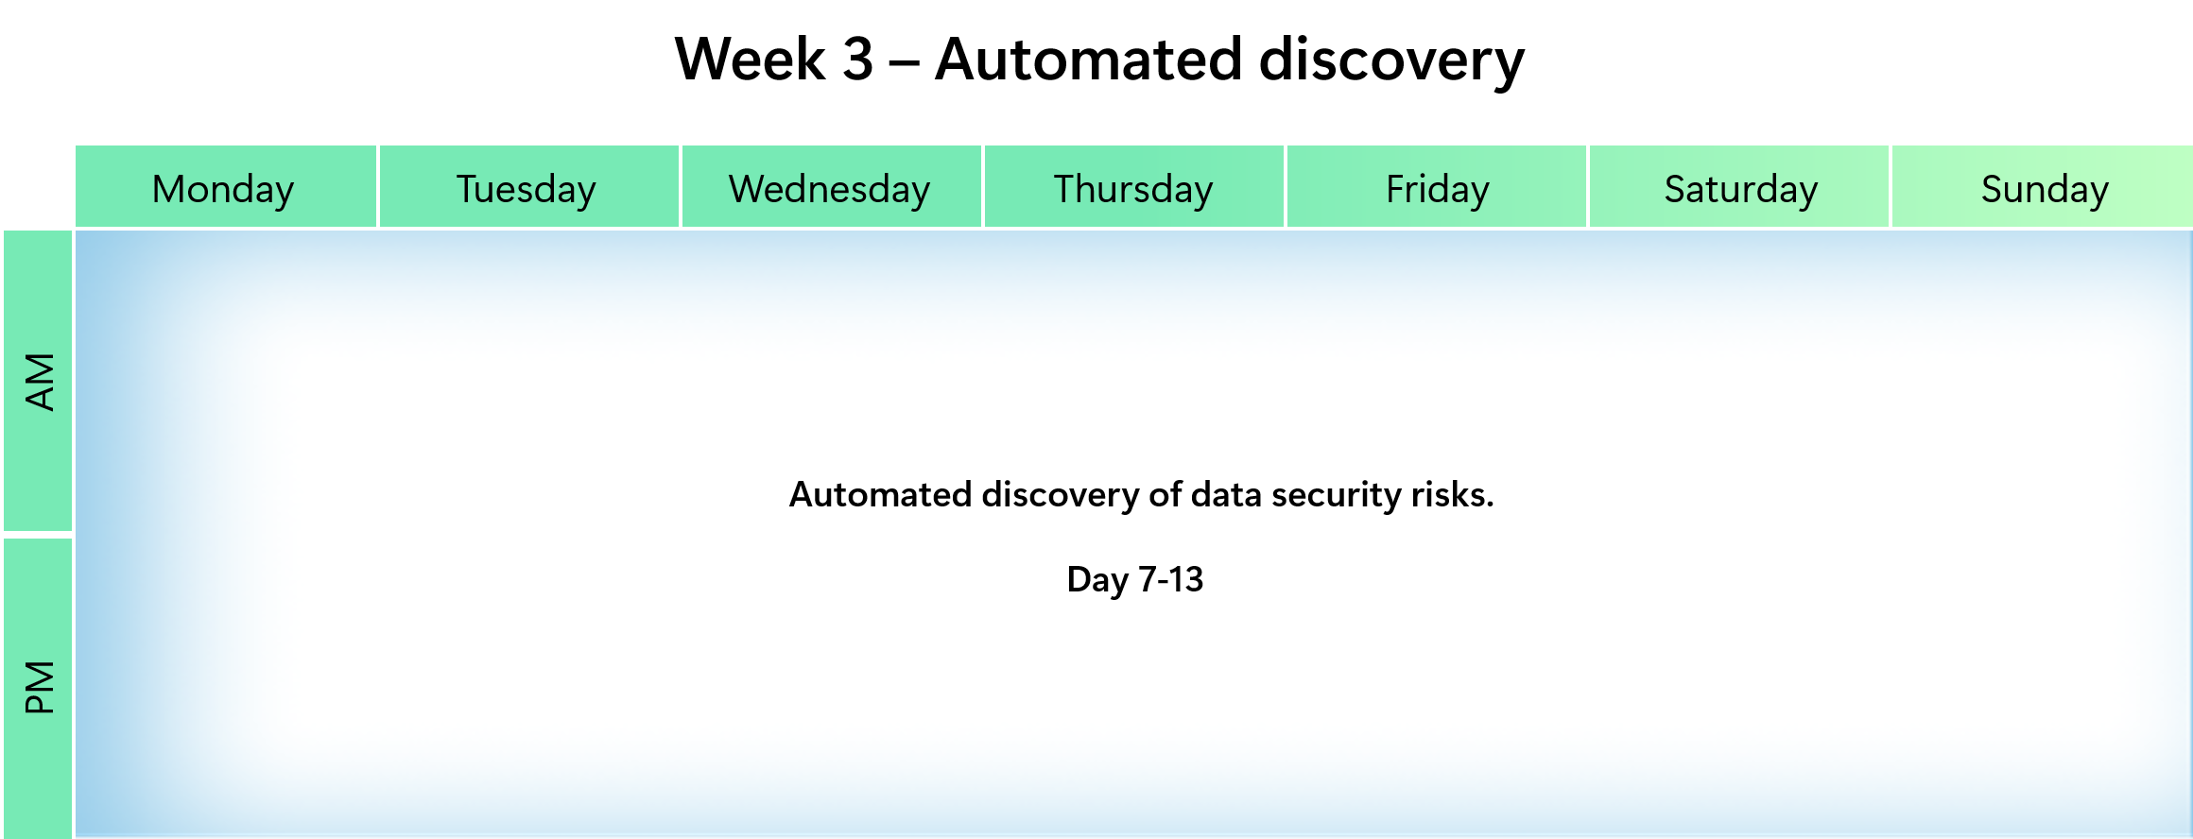
DELIVERY SCHEDULE
Update the delivery schedule using the PowerPoint file included in the toolkit:
<90 - Supporting Illustrations.pptx>
If the customer agrees to additional optional activities, add them to the schedule. Copy the updated illustrations to the statement of work.
Delete this textbox before publishing.

Week 4 - Analyze, report and workshop
The fourth week of the engagement is focused on preparing for the workshop delivery. The findings of the Data Security Check Automated Discovery will be collected, analyzed, and mapped to Microsoft solutions for risk mitigation and a detailed list of actionable next steps and recommendations will be created. During the workshop, the findings and identified risks will be discussed, possible solutions for risk mitigation will be presented, and a roadmap with actionable next steps and recommendations will be created.
The illustration below depicts the schedule for the fourth week of the engagement.
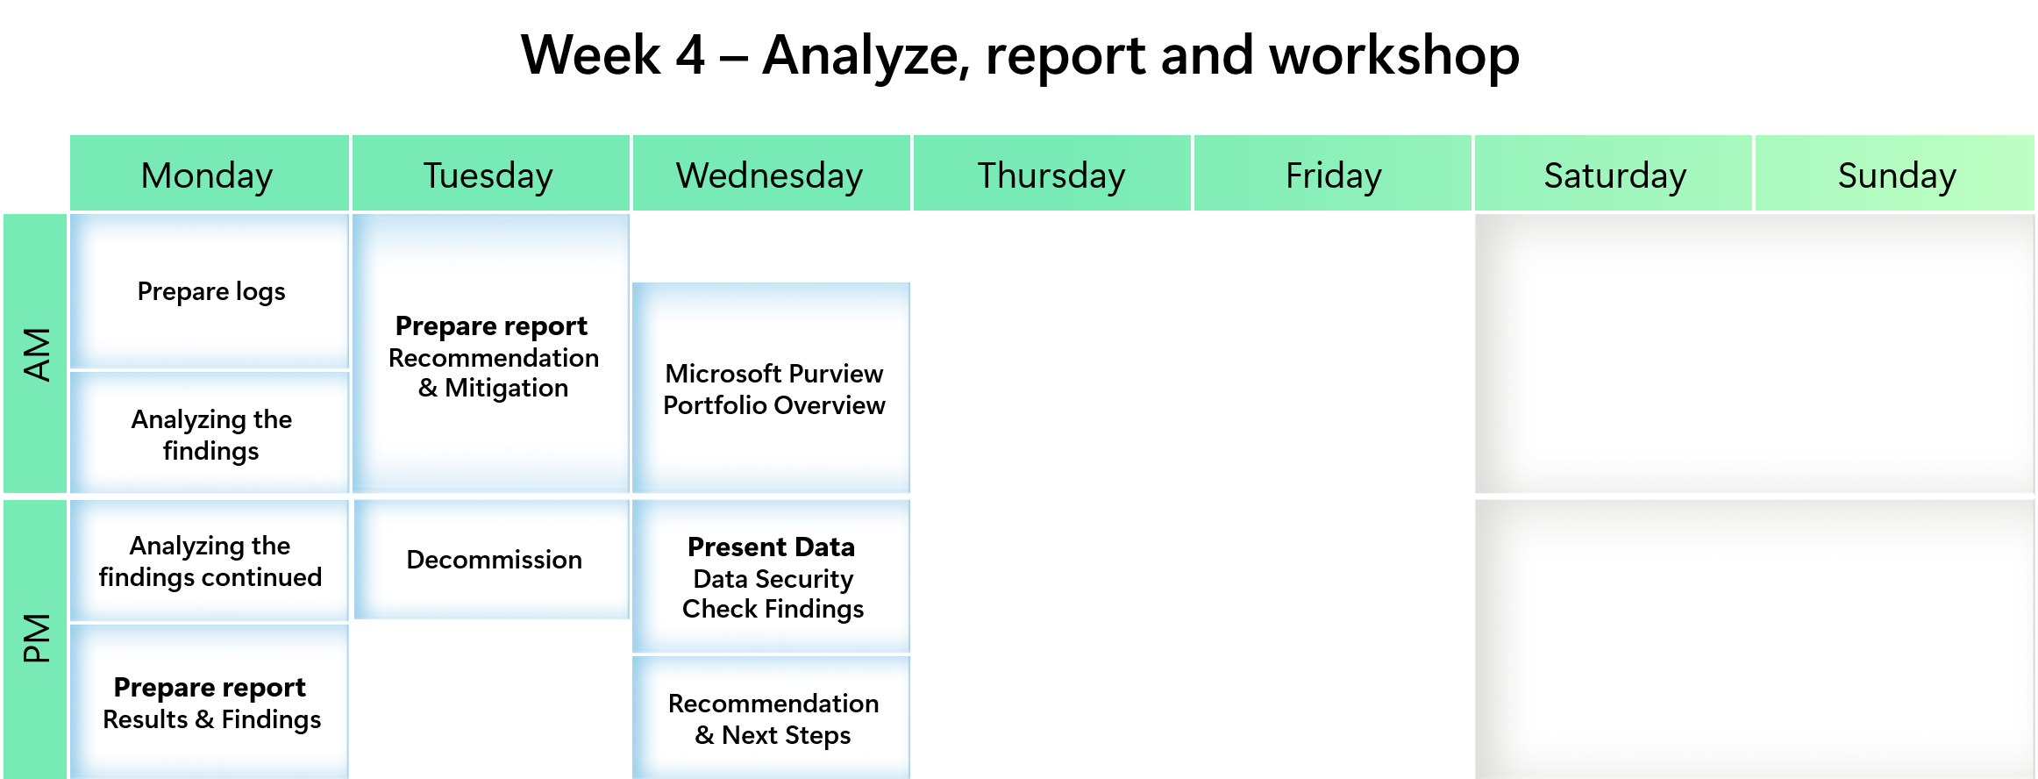
DELIVERY SCHEDULE
Update the delivery schedule using the PowerPoint file included in the toolkit:
<90 - Supporting Illustrations.pptx>
If the customer agrees to additional optional activities, add them to the schedule. Copy the updated illustrations to the statement of work.
Delete this textbox before publishing.

Effort
The table below provides an overview of the partner effort for the activities of the overall engagement as outlined before.
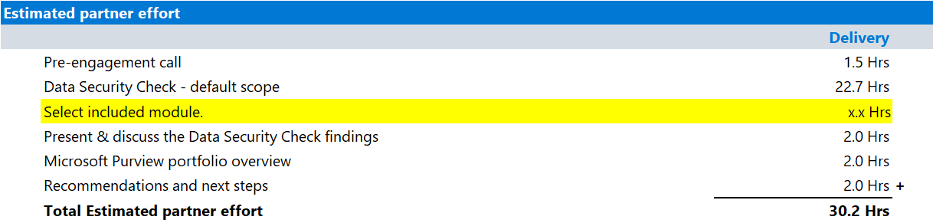
EFFORT ESTIMATES
Update the hours estimates using the Excel file included in the toolkit:
<04 - Hours Estimate.xlsx>
Include the additional effort for at least one (1) optional module.
The <04 - Hours Estimate.xlsx> includes estimates for all optional modules.
Copy the updated estimates from the Excel file for the modules that are included in the delivery.
Delete this textbox before publishing.

